Name:  Teacher: | ____________________________________  ________________ |  | Date:_________
 | Year 9 Mathematics  SCORE:  / 43  Mini test 5  Topic – Linear Equations  Full working out MUST be shown to get full marks for each question.
Total Time: | 55 minutes
Weighting: | 5 %
Equipment: | To be provided by the student: Pens and Pencils, scientific calculator, A4 page of notes.

Part A – Multiple-choice questions (5 marks)

- Which axis runs horizontally ?

A xy B y C x
D z E $∅$

2. How do you write an ordered pair ?

A ( x , x ) B ( y , x ) C ( y , y )
D ( x , y ) E ( x , $∅$ )

- What does ‘c’ represent in y = mx + c ?

A y - intercept B gradient C axis
D x - intercept E coordinate

- Write the equation of a line where the gradient is 0 and the y – intercept is 8.

A y = 8x B x = 8 C y = 8
D y = x + 8 E y = x + 8

- What is the gradient in the picture?

A = positive B = negative C = zero D = Undefined
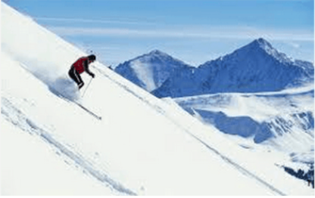

Part B Short Answer Questions:

6. ( 4, 2, 4 = 10 marks)

- Complete the following tables of values from the rule below.
$$y=2x-4$$
x | -1 | 0 | 1 | 2 | 3
y

- Plot the coordinates from your table of values in (i) on the graph below and draw a straight line connecting the coordinates.

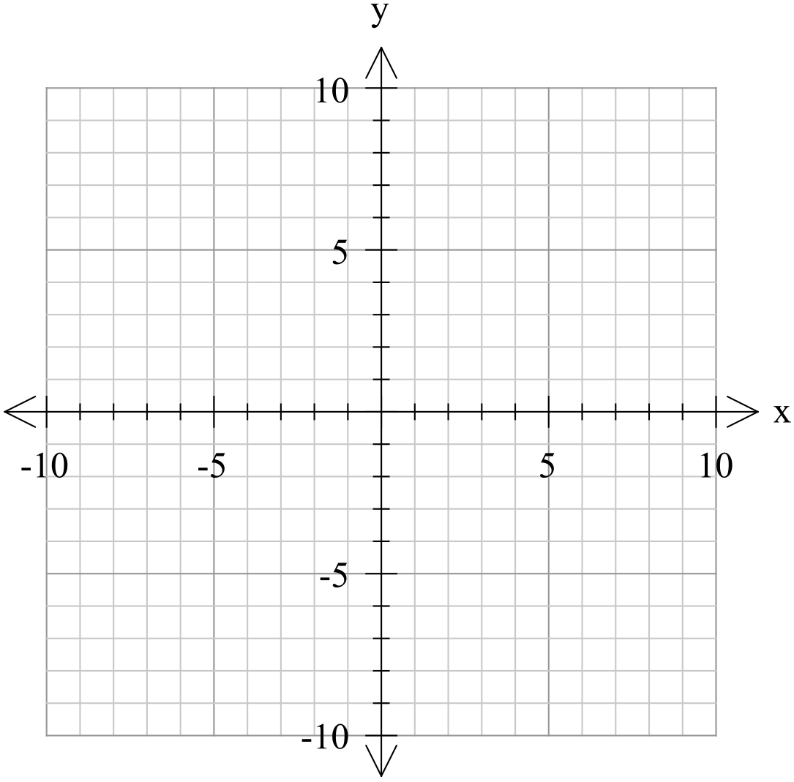

- From the graph, write the co-ordinates of the following:
x-intercept: y-intercept:

7. ( 2, 2, 2, 2, 2 = 10 marks)

Sketch the graphs of the following linear relationships (each small square = 1 unit).

  - $x=2$
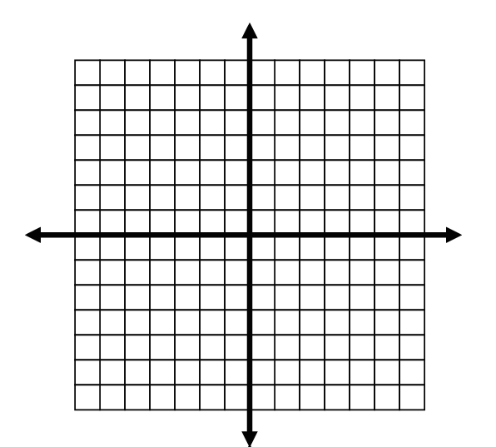


  - $y=-4$

  - $y=-x-3$

$$d. y=-2x+4$$



$$e. y=3x+1$$


8. Match the following graphs with their correct gradients: ( 4 marks )

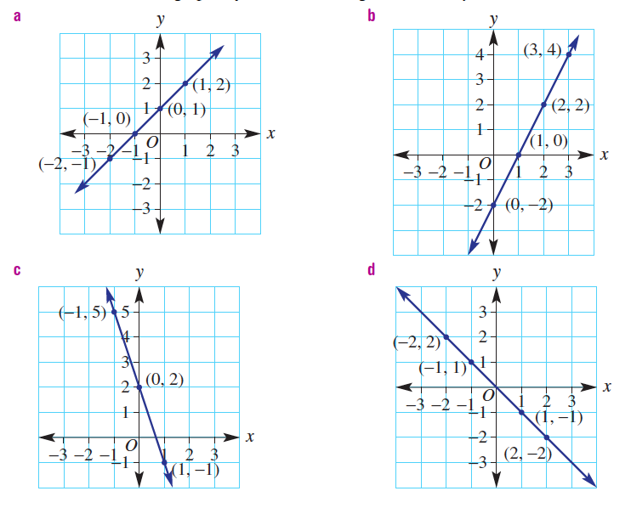

    - Gradient = -3: __________ iii) Gradient = 1: ___________

    - Gradient = 2: __________ iv) Gradient = -1: ___________

9. (2 marks)

Find the distance between and the midpoint between these two co-ordinates, (2,5) and (8, -4),

10. (4, 4, 2, 2 = 12 marks)

Phoebe’s family decide to get a new pool and they ask her to calculate how long the pool will take to fill. Phoebe works out that the volume of water ($v$) in the pool is given by the equation $v=350t$ where $t$ is the time in hours.

  - Use the rule to complete the table of values.
$$t$$ | 0 | 30 | 60 | 90 | 100
$$v$$

  - Graph this relationship. Volume of water vs time
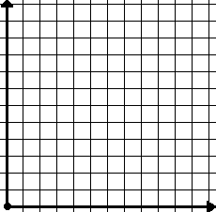

  - If the pool is full after 70 hours, use your graph to estimate the volume of the pool (Show any working on the graph).
Estimated volume = _________________

  - Check your answer by substituting the relevant value into the equation. (Show your working)

Calculated volume = _____________

End of test

